Internal Assessment 2 Storyboard
Very Vegan Cafe

University of Technology, Jamaica
School of Computing and Information Technology
Web Programming (CIT2011)

Camara Daley (2302245)

Due Date: November 21, 2025
Lecturer: Ms. C Anuli
Occurrence: UE-1
Tutorial: Thursday 8PM

Storyboard for Very Vegan Café Website
Hosting Link:
https://camaradaleyedu.github.io/InternalAssessment2/index.html

Business Description
Very Vegan Cafe is a quick-service, health-focused restaurant dedicated to providing delicious, plant-based meals and fresh beverages to locals and visitors in a welcoming, environmentally conscious setting. Our focus is on high-quality, locally sourced ingredients to promote health and sustainability.

Mission Statement: To serve wholesome, innovative, and ethically sourced vegan cuisine that encourages healthy eating habits and supports environmental sustainability within our community.
Vision Statement: To be the leading fast-casual vegan dining destination recognized for outstanding food quality, environmental stewardship, and promoting a vibrant, plant-based lifestyle.
Logo is A stylized, brown tea cup spelling out "Vegan Cafe." The primary colors are deep green and earthy brown.

- Description of the Intended Audience
The intended audience for the Very Vegan Cafe website is diverse, encompassing several key demographics:
- Primary Audience: Health-Conscious Millennials and Gen Z (Ages 18–40). This group is highly active online, values ethical and sustainable practices, and seeks convenient, transparent food options. They primarily use mobile devices for ordering.
- Secondary Audience: Vegetarians, Vegans, and Individuals with Dietary Restrictions. This includes those who actively seek out plant-based menus due to ethical beliefs, allergies, or specific health goals. They prioritize detailed ingredient lists and clear labeling.
- Tertiary Audience: Local Office Workers and Tourists. Individuals looking for a quick, healthy lunch option ("Pickup / Takeout" option) or a casual dining experience ("Dine In" option), who appreciate the quality and speed of service.
- The website is designed to be minimal, mobile-friendly, and fast, offering clear navigation and a seamless checkout process to cater to the primary audience's need for convenience.

- The color palette for the Very Vegan Cafe website is chosen based on the psychological impact of colors, particularly to evoke feelings of health, freshness, and nature, which aligns perfectly with the brand's core values.
- White signifying purity, innocence, freshness, and cleanliness Used for the main background and negative space to enhance readability, signify cleanliness, and make the food photography pop.
- Green which is reassuring, grounding, balance, health, nature, and freshness. It is calming and restful. Used as the primary colour for headers, buttons, and backgrounds, directly linking the brand to fresh ingredients, growth, and natural health.

- 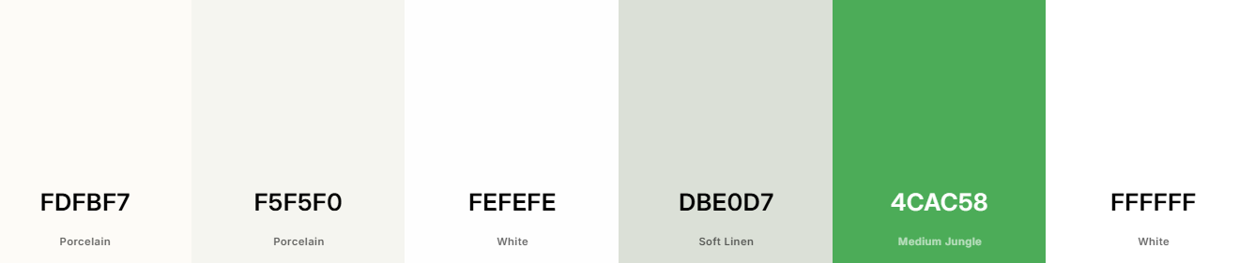
- Layout Designs:
- Mobile (min 600px): Includes header-nav, hero, menu-section, footer. Items stacked vertically.
- Desktop (min 950px): Horizontal navigation, two-column hero, 3-column menu item rows.
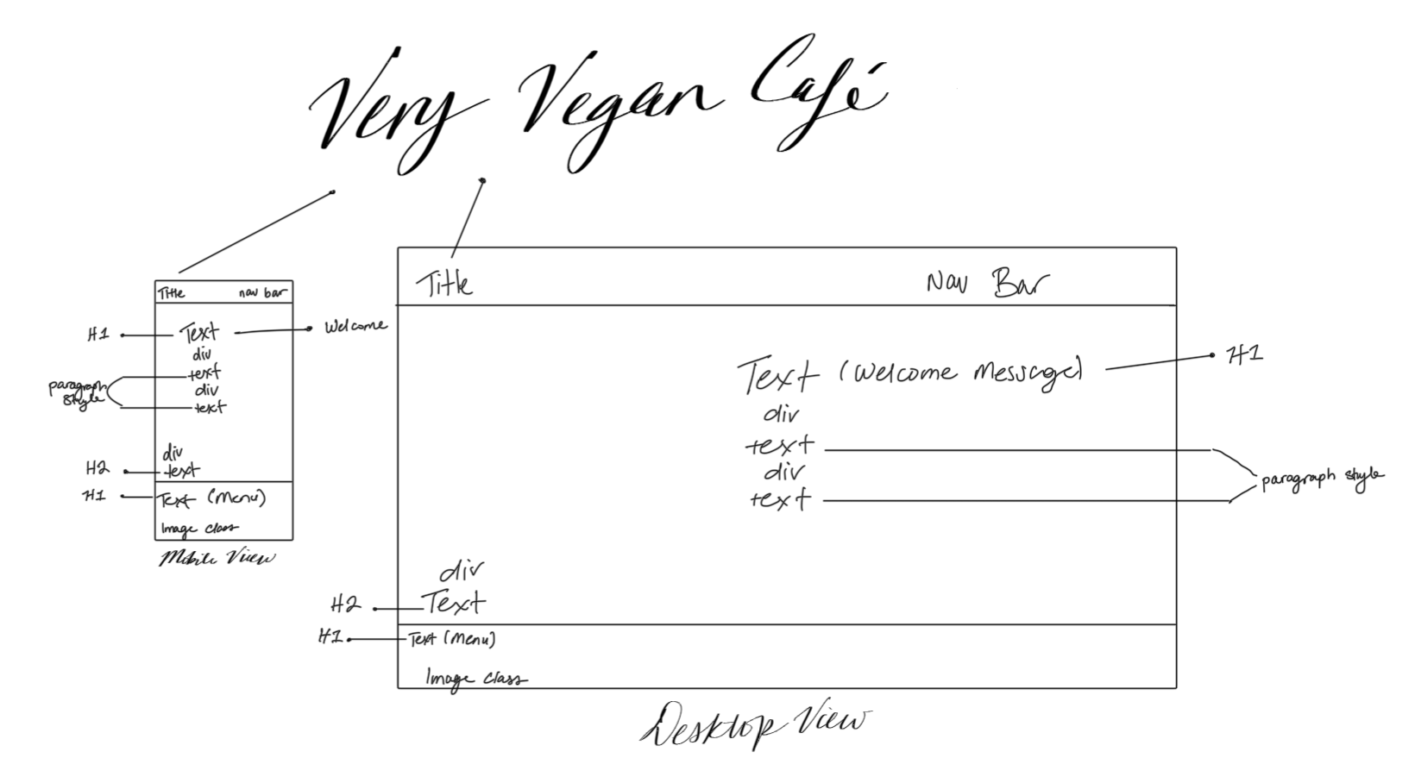
- Icons:
- Receipt/Paper icon

- Typography:
- Font-family system-ui, sans-serif
- Root font-size: 16px
- Root font-weight: 400
- Headings: 700 weight

- User-defined Functions:
- addToCart(itemId): Adds menu item to cart.
- updateCartDisplay(): Updates cart count and display.
- loadMenuCategory(categoryName): Loads items by category.
- filterMenuItems(searchText): Filters displayed items.
- initializeSite(): Sets up listeners and defaults on load

References
Envato (Channel Name)2021, March 18Color Psychology | Red, Blue, Yellow, Green, Pink, White, Black, Gray and Gold [Video].https://www.youtube.com/watch?v=8J0nbuunDXc

